SQL Advanced Data Analytics

Analyze Sales Performance

* Change over time Trend Analysis
* Cumulative Analysis
* Performance Analysis
* Proportional Analysis (Part to whole Analysis)
* Data Segmentation
* Make the Product and Customer Report

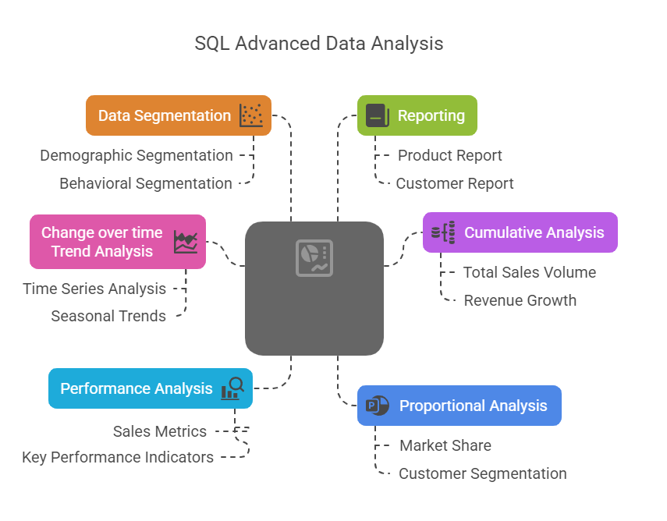

======================================================================

Product Report

======================================================================  
Purpose - This report consolidates key Product metrics and behaviours

Highlights:

1. Gathers essential fields such as Product Name, Category, subcategory and cost.
2. Segments Product by revenue to identify High-Performance, Mid-Range or Low-Performance.
3. Aggregates Customer-level metrics:  
   - Total Sales  
   - Total Orders  
   - Total Quantity Sold  
   - Total Customers (Unique)  
   - Lifespan (in Months)

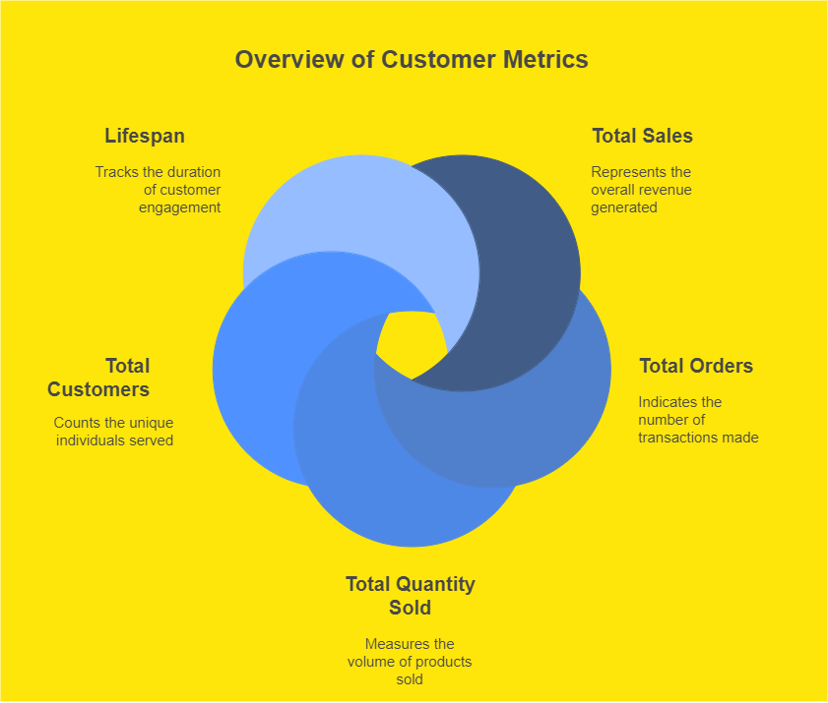

4 - Calculates valuable KPI's

* Recency (Month Since last Sale)
* Average Order Revenue (AOR)
* Average Monthly Revenue

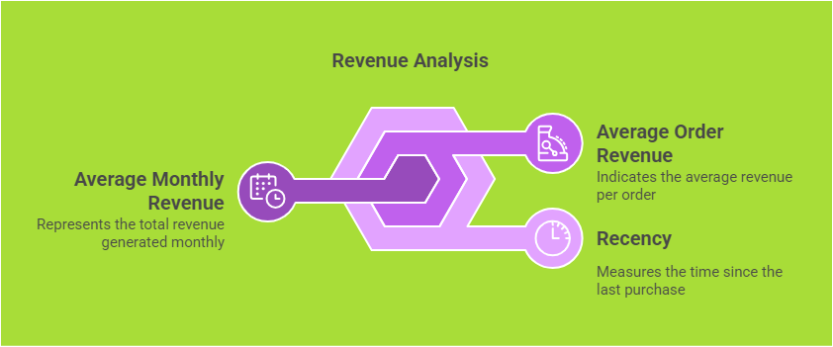

Customer Report

======================================================================

Purpose - This report consolidates key customer metrics and behaviours.

Highlights:

1. Gathers essential fields such as names, ages, and transaction details.
2. Segments customer into categories (VIP, Regular, New) and Age groups.
3. Aggregates customer-level metrics:
   * Total Sales
   * Total Orders
   * Total Products
   * Total Quantities Purchased
   * Lifespan (in Months)

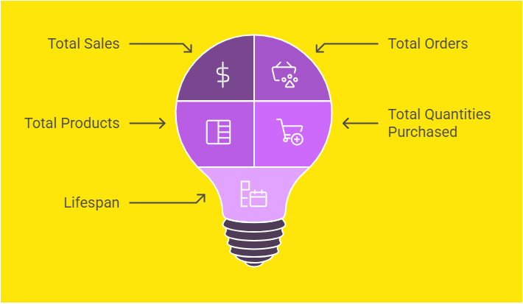

4. Calculates valuable KPI's

- Recency (Month Since last order)

- Average order value

- Average Monthly spends

